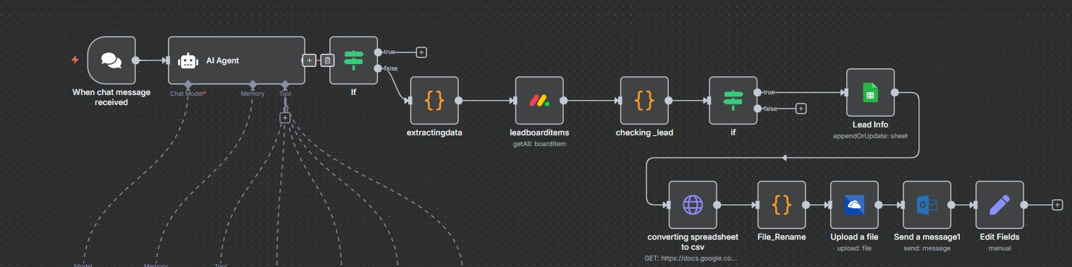

Overview:
This project is an “automated chatbot workflow built using n8n”. It uses an AI agent to collect lead information through chat messages, verifies whether the lead exists, and stores the data in a Google Sheet. It also handles file conversion and delivery.

Objective:
- Automatically capture user inputs from chat.
- Use AI to extract lead details (e.g., name, email, phone).
- Check if the lead already exists.
- Append or update the Google Sheet.
- Convert the updated sheet to CSV and deliver it to a defined destination or system.
- Send acknowledgment messages to users.

Tech Stack:

Component | Tool/Service
Workflow Engine | n8n
AI Processing | n8n AI Agent
Data Storage | Google Sheets
File Conversion | n8n HTTP Request
File Delivery | Upload/File Node
Messaging | Send Message Node
Scripting/Logic | JavaScript/If, Edit Fields

Detailed Task-by-Task Breakdown:

- Add “On chat message” trigger (Trigger node)

Purpose: Initiates the workflow. It's configured to listen for incoming messages from a chat platform (e.g., Slack, Telegram, Discord).

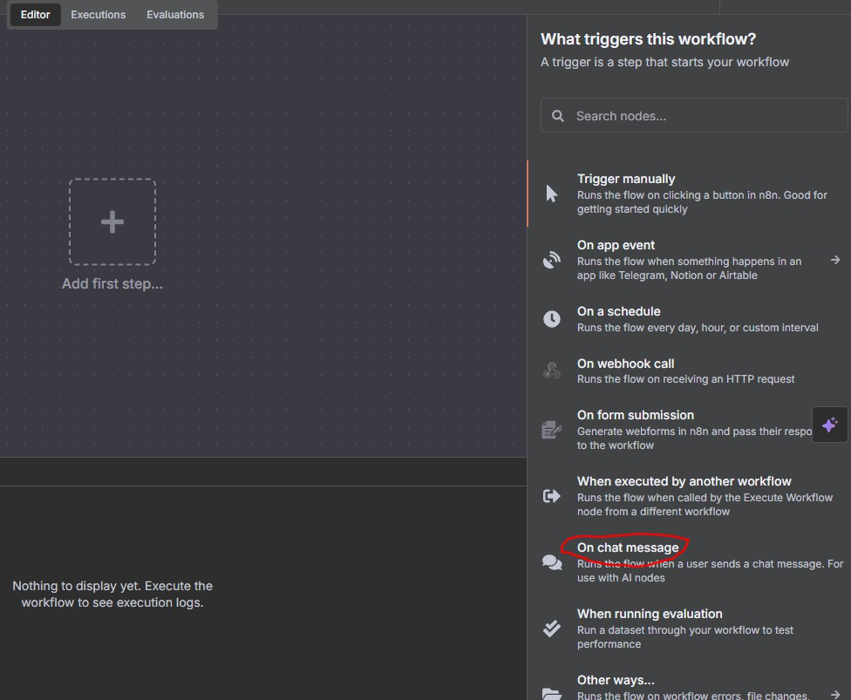

- Double-click on “When chat message received”and it will bring up the properties of the function. Turn on “Make Chat Publicly Available”. That will give you the chat URL to implement on the web interface. You can change the initial message as well.

Technical Details: This node acts as a webhook listener. When a message is received, it captures the payload, which typically includes the message text, sender's ID, timestamp, and other metadata. This data is then passed to the next node in the workflow. The "Chat Model" and "Memory" inputs suggest it might be integrated with a specific AI chat model framework, storing conversation history for context. The lightning bolt icon indicates it's an active trigger.

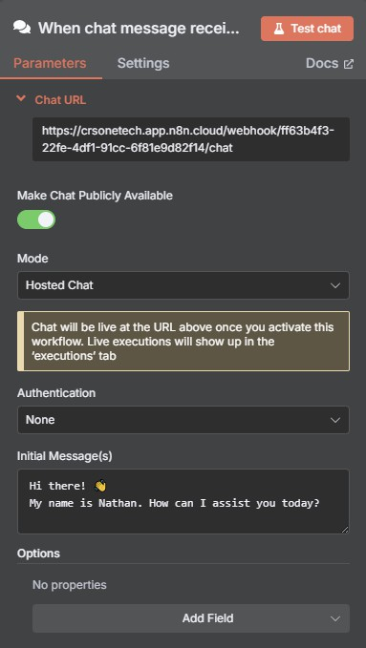

- Next you want to add an AI agent. Click on the connector, choose AI, select AI Agent

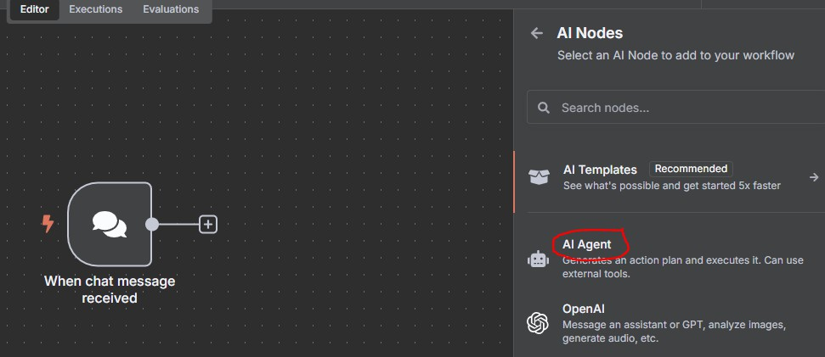
Purpose: Processes the incoming chat message using a large language model (LLM).

- Double-click AI Agent to open the properties. This is what it should look like: Uses a chat model to interact with users.Extracts lead details (like name, email, phone).Works with memory and tools (like Google Sheets API).
Technical Details: This node likely uses an n8n integration for a service like OpenAI's GPT, Anthropic's Claude, or another similar model.
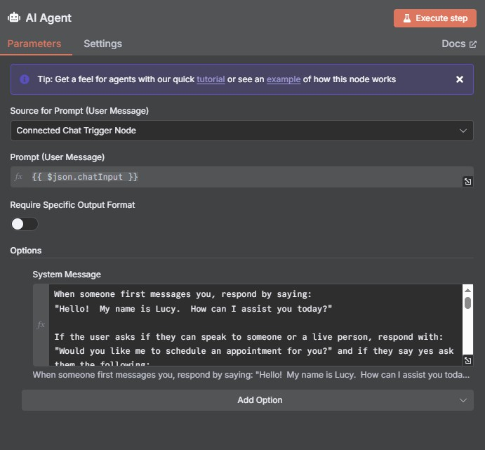

Prompting in AI Agent:
You are a lead generation assistant for 360DMMC. Your task is to collect the following details one-by-one:
- Full Name
- Email Address
- Phone Number
Ask each question politely, and wait for the user's reply before asking the next. After collecting each answer, store them in memory using the keys: `name`, `email`, and
`mobile`.
Once all three are collected, display a confirmation message like this:

"Great! Your details have been successfully recorded:
- Name: {{name}}
- Email: {{email}}
- Mobile: {{mobile}}

Thank you for providing your information. A member of the 360DMMC team will contact you soon."
Important: Do not skip any steps. Always ask for full name, then email, then phone.

- You need to add a “if condition option” Checks if extracted data is valid (truthy check). (Logic/Conditional node.)

Purpose: To branch the workflow based on a condition.

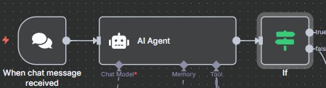

- Double click on “if condition option” if the function template placeholder if the data is not present then only it is continued to the next stage
Technical Details: The node evaluates a boolean expression. In this case, it's likely checking the output of the "AI Agent" node. For example, it could check if the agent's output is structured data that can be processed further (the true branch) or if it's a simple text response that should be sent back to the user (the false branch). The condition is defined by an expression, such as {{ $json.data.should_process }}.
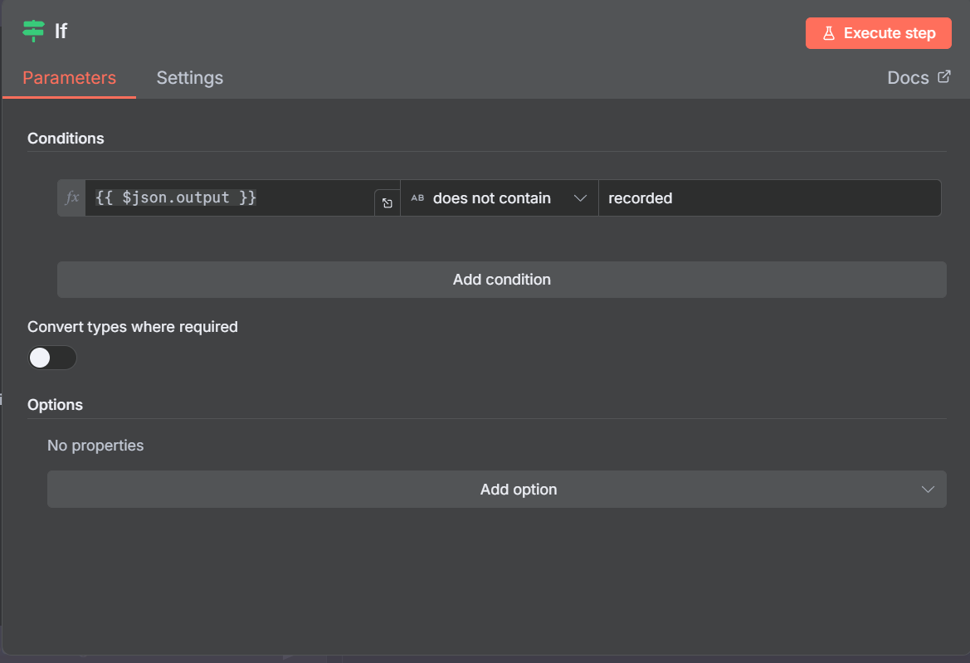

- You need to add a Extracting Data option after the if condition (Data Processing Node)
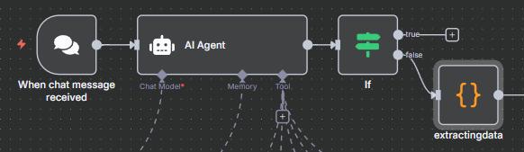
Purpose: To parse and format the data from the "AI Agent" node's output.

- Double click on to the “Extracting Data option” Extracts structured data from the AI agent’s output.

Technical Details: This is a custom code node where JavaScript is typically used. The code would take the raw output from the AI agent (e.g., a JSON object or string) and extract specific fields like a lead name, email, company, or other relevant information. It might use JSON.parse() or regular expressions to structure the data for the next steps.
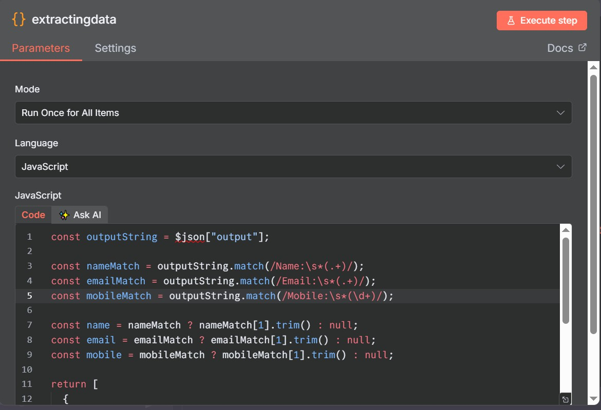

- You need to create a LeadBoardItems option to getAll: BoardItem Fetches existing leads from the data source (Integration Node)

Purpose: To retrieve existing data from an external service.
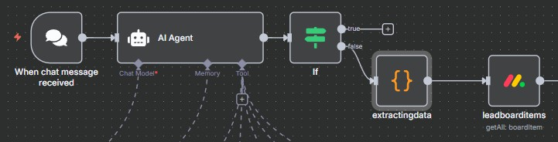

Then after, Double click on to the “LeadBoardItems” Option it will redirects to the Monday.com account

Technical Details: This node is configured to make an API call to a service. The "getAll: boardItem" suggests it's fetching all items from a specific board. It would be configured with API credentials (API key, token), the specific endpoint URL, and any necessary query parameters to get the data. It's likely retrieving existing leads to check for duplicates later.
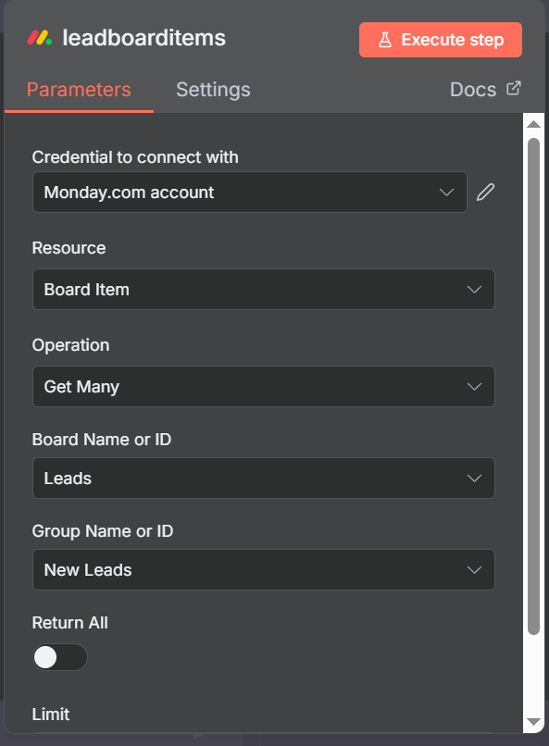

- You need to add an Checking Lead option Compares extracted lead against existing leads. (Data Processing Node)

Purpose: To compare the newly extracted data with the existing data retrieved by the
leadboarditems node.
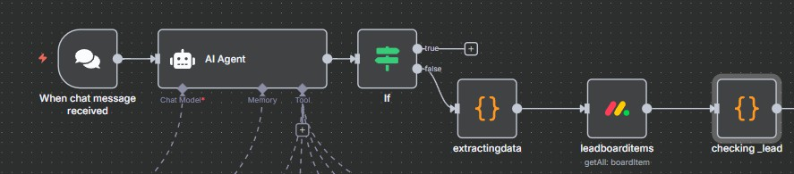

- By Double clicking on to the Checking Lead option it validates duplicates using email/phone.

Technical Details: Another custom JavaScript node. It iterates through the list of existing leads and checks for a match with the new lead's data (e.g., by email address, name). The code would return a boolean value or a new data structure indicating whether a duplicate exists.
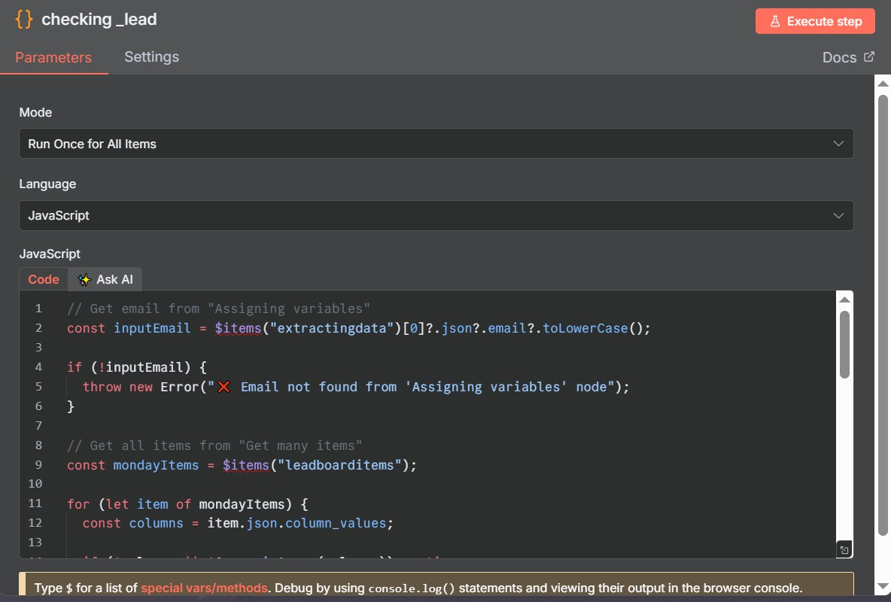

- You Need to create a if condition option2.If lead is new, proceed to append.(Conditional Splitter)

Purpose: To decide whether to update an existing lead or create a new one.
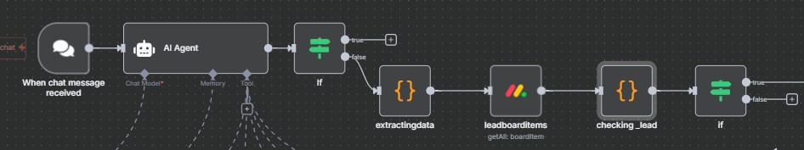

- By Double clicking on to the if condition option2. If already exists, either skip or update.

Technical Details: This node evaluates the output of the checking_lead node. If the lead is a duplicate (true branch), the workflow proceeds to update the lead. If it's a new lead (false branch), it proceeds to a different path (not shown in full, but likely an "add new lead" path).

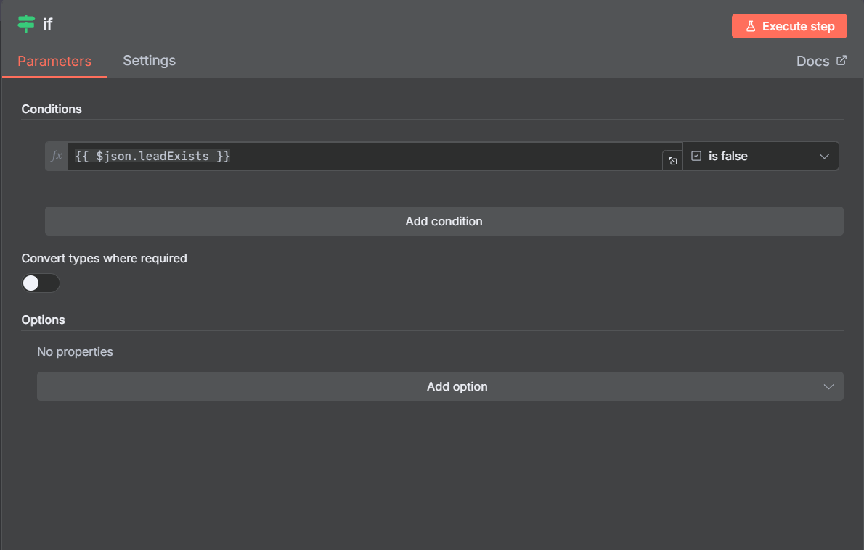

- You Need to create a new option called LeadInfo which append or update the sheet
(Data Manipulation Node)

Purpose: To append or update data in a spreadsheet.
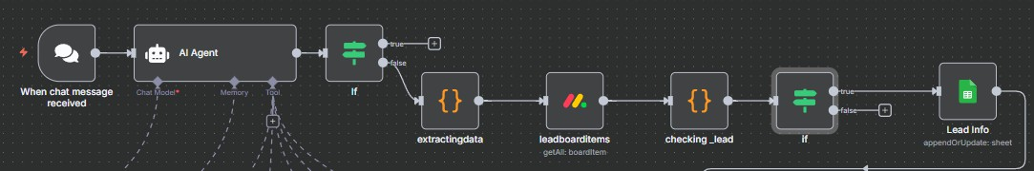
- By Double click on the “LeadInfo” option then it will Appends new lead or updates an existing entry in Google Sheets.

Technical Details: This node uses an n8n integration for a spreadsheet service. The "appendOrUpdate: sheet" operation indicates that it will either add a new row to the specified sheet or update an existing row if a matching key is found. It's configured with the spreadsheet's URL/ID, the sheet name, and the data to be written (the extracted lead info).

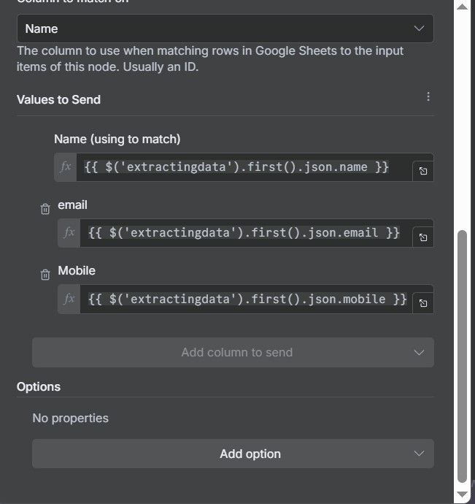

- You need to create Converting spreadsheet to csv option (HTTP Request/Web Service node)

Purpose: To fetch and convert a spreadsheet into a CSV file.

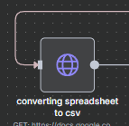

- By Double click on to the “Converting SpreadSheet to csv” option Converts Google Sheet to a downloadable CSV using an HTTP GET request.

Technical Details: This node makes an HTTP GET request to a URL. The URL "https://docs.google.co..." suggests it's a Google Sheets export URL specifically formatted to download the sheet's content as a CSV file. This node would handle the API authentication and the download of the file's binary content.
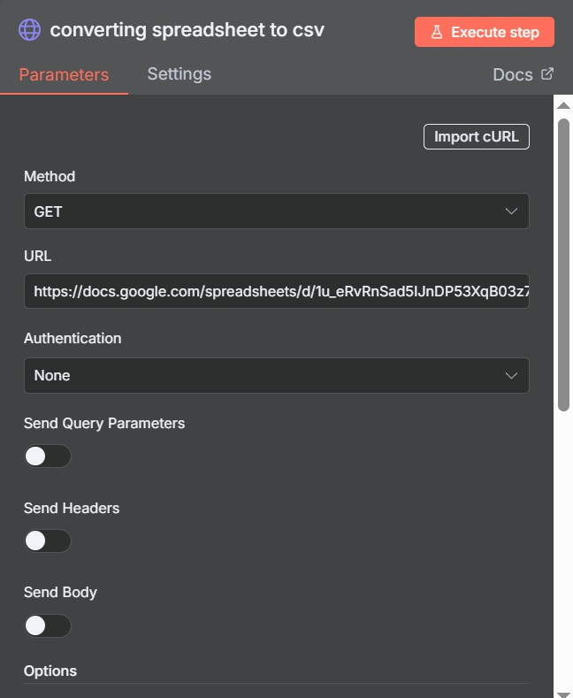

- You need to create a File Rename option (Data Processing Node)

Purpose: To rename the downloaded file.
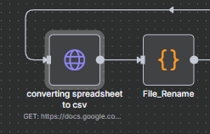

- By Double click on to the “File Rename” Option Renames the downloaded file to a friendly name (e.g., leads.csv).
Technical Details: A custom JavaScript node. It takes the binary file data from the previous node and changes its metadata, specifically the filename. The code would set a new name, potentially based on the current date or a variable, for example, {{ now('YYYY-MM-DD') }}_leads.csv.
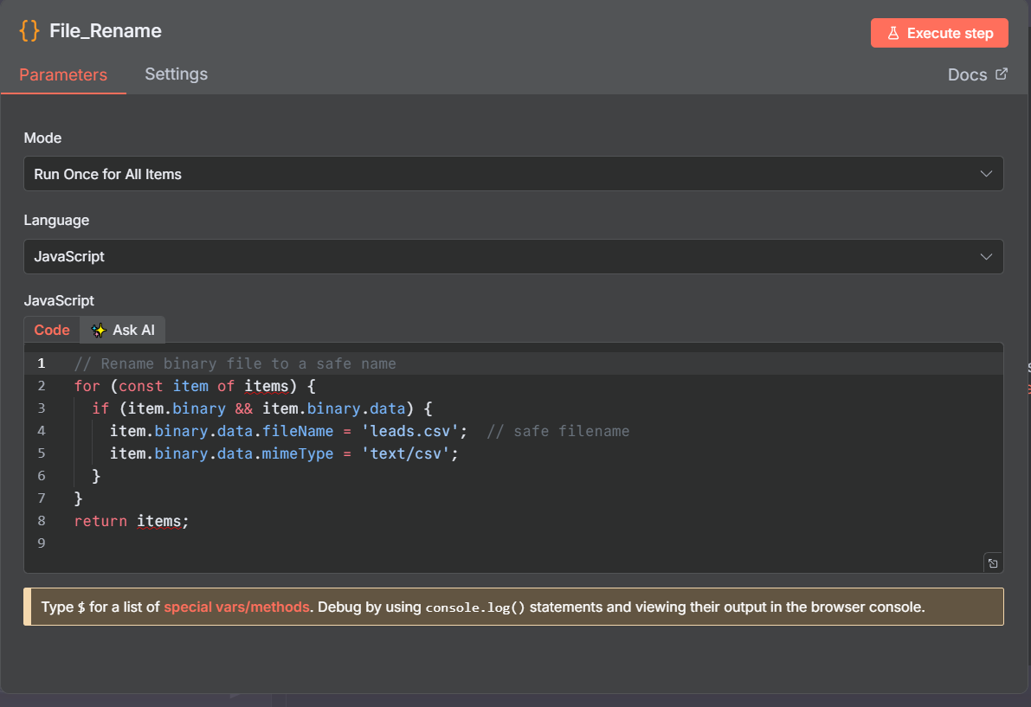

- You need to create a Upload a file option (Integration Node)

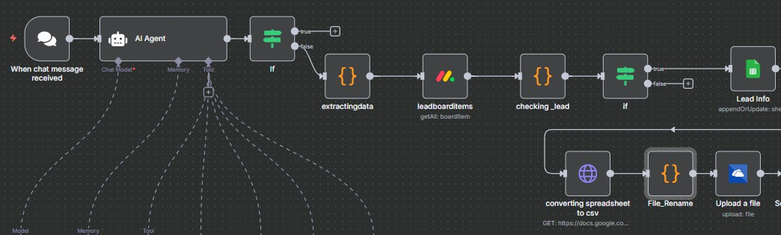
Purpose: To upload the renamed CSV file to cloud storage.

- Double Click on to the “Upload a file” option Uploads the CSV to a defined destination (Google Drive, S3, etc.).

Technical Details: This node is configured with the cloud service credentials, the target folder path, and the file data from the previous File_Rename node. It executes the API call to upload the file.
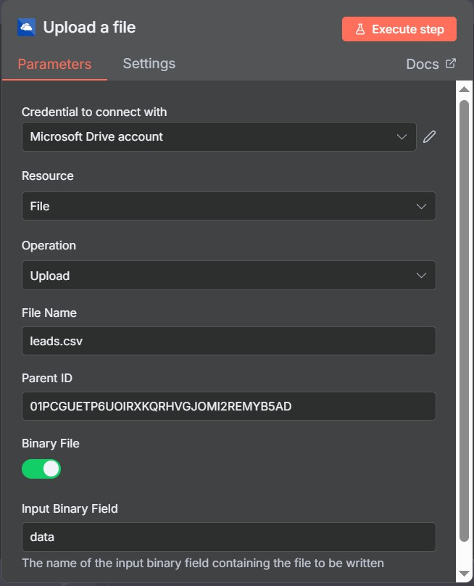

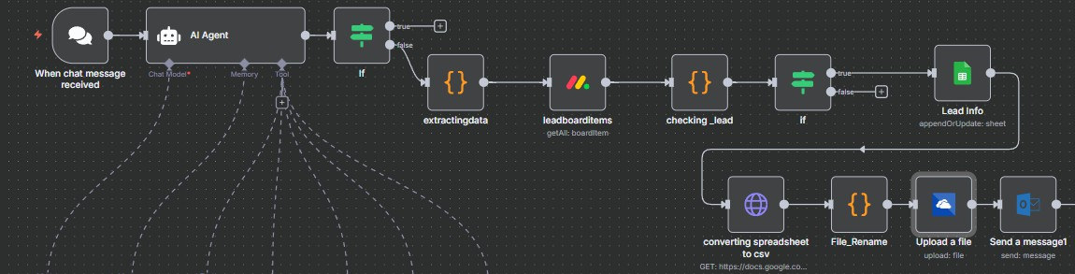
- You need to create a new option called Send a message option Purpose: To send a notification message.

- Double click on to the “Send a message” option. It Sends a confirmation or status message to the user.

Technical Details: This node sends a message to a configured recipient. It's configured with the target channel/email address and the message content, which could be a static string like "Daily lead export complete!" or dynamic content like the URL of the uploaded CSV file.
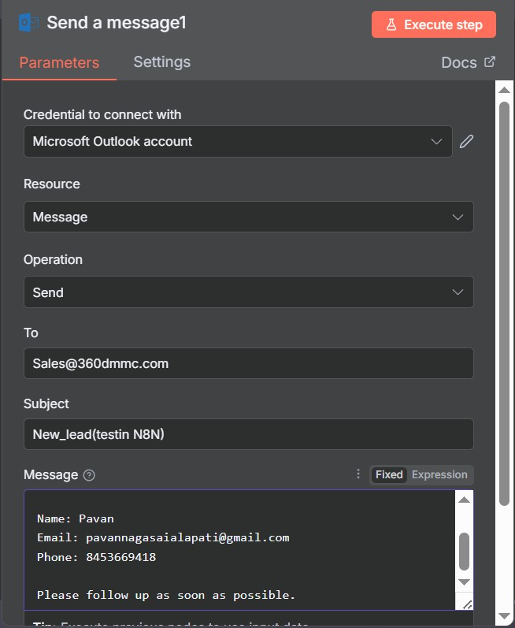

- You Need to create an Edit Fields option (Utility/Manual input node)

Purpose: To manually edit or transform data before sending it to another process.

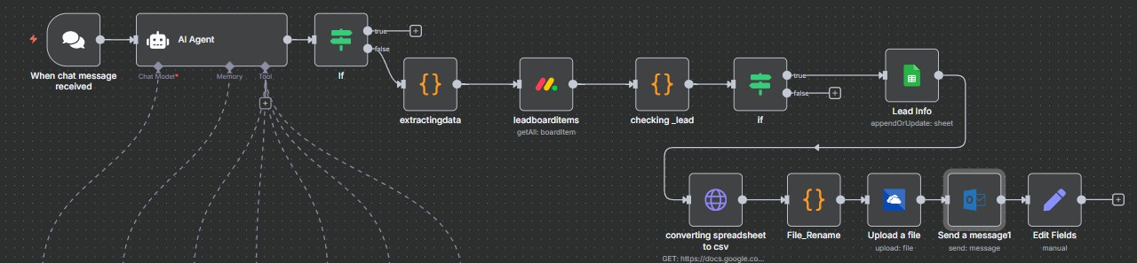

- Double clicking on to the “Edit Fields” option It does a Optional manual field edit or placeholder for admin override.

Technical Details: This node sends a message to a configured recipient. It's configured with the target channel/email address and the message content, which could be a static string like "Daily lead export complete!" or dynamic content like the URL of the uploaded CSV file.

